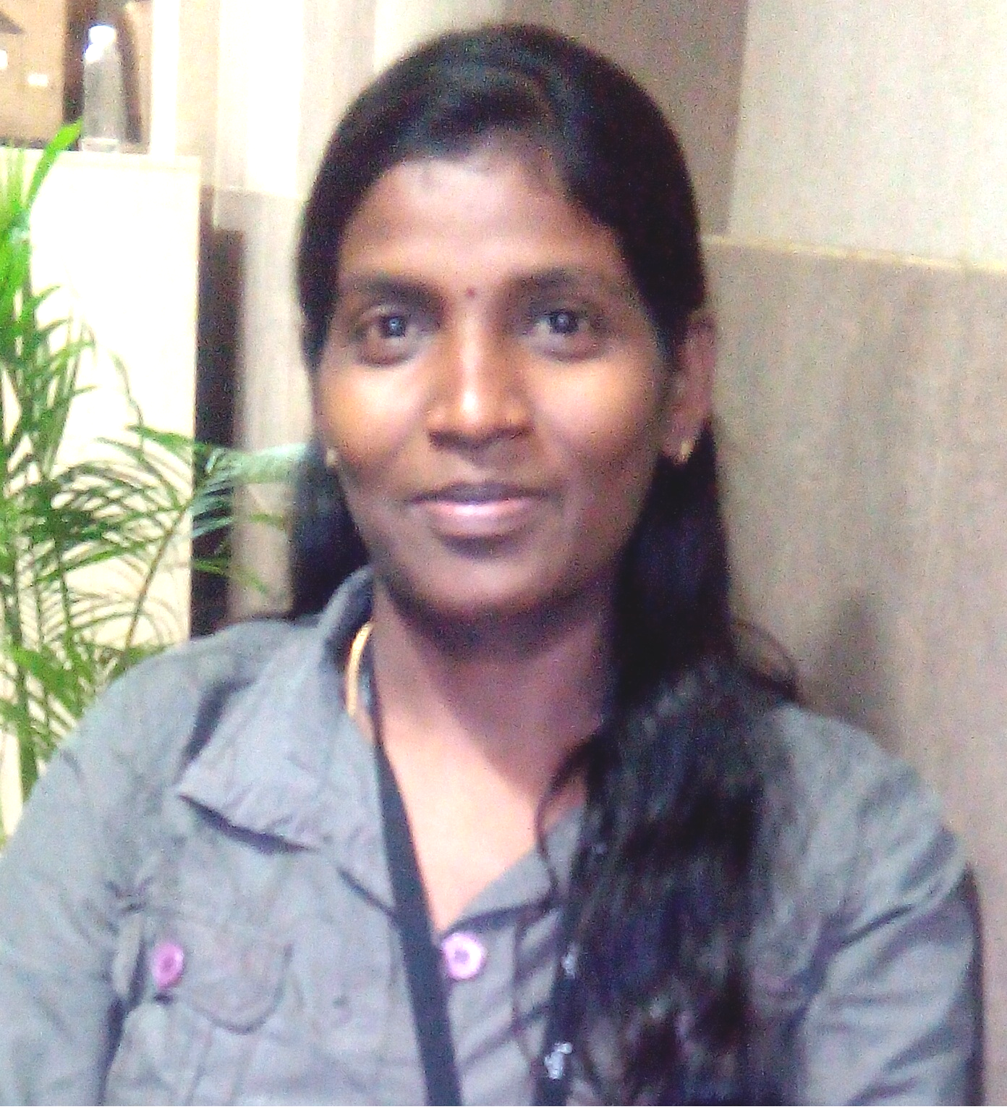
JULIE MARY G
Contact: +91 9884-474-717
E-Mail: juliemarytw@gmail.com

LEAD TECHNICAL WRITING PROFESSIONAL
Technical Writing
Proven record of drafting and reviewing/editing content on release notes, online help, user manual, installation guide, admin guide, troubleshooting guide, Proposals, Newsletter, and PPTs

Location Preference: Chennai Industry Preference: IT – Software

PROFILE SUMMARY

- Dynamic professional offering over 20+ years of rich experience in project management, technical writing and quality management, team management, requirement gathering, manual testing, and proposal writing.
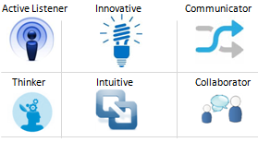
- Domain expertise lies in leading software documentation, including release plan announcements, release notes, user’s guides, online help, features lists, product promotion kits, training materials, and other internal software documents.
- Abilities in the creation and maintenance of customer-facing technical documentation for applications; functioning as the owner of software documentation.
- Hands-on skills in using tools such as IXIASoft, Zoomin, DITA, Madcap Flare, Central, SnagIt, Adobe Acrobat, Adobe RoboHelp, Adobe FrameMaker, and MS Office tools.
- Effective leader with excellent motivational skills to sustain growth momentum and motivate individual performances.

CORE COMPETENCIES

- Working with internal teams & onsite teams to obtain an in-depth understanding of the product and the documentation requirements as per norms.
- Creating and maintaining the information architecture and mentoring teams as per schedule
- Producing high-quality documentation that meets applicable standards and is appropriate for its intended audience such as online users.
- Writing easy-to-understand user interface text, online help, and developer guides; creating tutorials to help end-users use a variety of applications.
- Suggesting new and revised existing plans for initiating software documentation to ensure technical accuracy, readability, and consistency.
- Defining and delivering quality documentation for new software products, major releases, release updates, etc.
- Collaborating with internal teams (developers, architects, analysts, consultants, and account managers) to ensure their needs are met by existing documentation.

WORK EXPERIENCE

Since Apr’23 to Till Date: DSA Loans Private Ltd. Chennai

Role:
- Playing as a Detail-oriented, highly focused, and self-motivated writer/editor/manager
- Having excellent organizational, planning, time management, and communication skills
- Mentoring team members and preparing process doc for the loan process
- Maintaining docs in Word, RoboHelp, FrameMaker, and Madcap Flare tools
- Document User Guides, Admin Guide for iPhone using MS Word
Since Jul’18 to Apr’23: ASG- Rocket Software, Chennai

Growth Path:
Jan’22 – Apr ’23: Manager, Information development (M3)
Jan’21 – Dec’21: Technical Writer & Quality Manager (M1)
Jul’19 -Dec’20: Team Lead - Technical Writer (TW3)
Jul’18 – Jun’ 19: Senior Technical Writer (TW2)

Role:
- Leading a team of 7 technical writers and independent writers for four mainframe products.
- Authoring IXIASoft tool and publishing the content in the zoomin portal by following IBM standard guides
- Handling organizing sessions on e-learning tools such as Madcap Central tools
- Following issues in the JIRA board
- Initiating requirement gathering from SMEs, Business Analyst for preparing guides
- Preparing documentation plan for drafting content for user’s guides and online help
- Creating style sheets for online help systems and printed user manuals
- Scrutinizing and editing the initial draft and proof-reading the content by verifying the functionality of the application
- Assessing the software documentation process such as release notes, printed user’s guide, online help, installation guide, configuration guide, migration documentation, posting documents to the site
- Performing a gamut of operations such as:
- Formatting and integrating images for guides
- Self-reviewing, peer / technical reviewing, and proofreading of documents
- Delivering the guides in HTML and PDF file format
- Maintaining the guides in Bitbucket and Madcap Central

Mar’16 – July 18’: Infinite Computer Solutions. Chennai

Role:
- Playing as a Detail-oriented, highly focused, and self-motivated writer/editor/manager
- Having excellent organizational, planning, time management, and communication skills
- Having proven ability to juggle multiple projects in a fast-paced, deadline-driven environment
- Having Strong networking and leadership qualities, promoting a team environment
- Interviewing SMEs to understand the product workflow
- Defining Templates and Style sheets for Product Manuals
- Document Online Help Files using RoboHelp and SnagIt
- Document User Guides, Admin Guide for iPhone using MS Word
- Document What's New Release for the latest enhancements
- Document Quick Reference Guide for the product
- Document and track the latest enhancements using JIRA
- Defining Document Review Checklist
- Drafting and reviewing Content for Product
- Capturing and Integrating images into manuals
- Doing Peer Review with Technical Team
- Delivering the final Output to the respective managers
- Archiving the draft and final documents into Spandan

May’15 – Jan 2016: InfoTrellis Inc. Chennai

Role:
- Initiating requirement gathering from SMEs, Business Analyst for preparing guides
- Preparing Newsletter for organization.
- Preparing documentation plan for drafting content for user’s guides and online help
- Creating style sheets for online help systems and printed user manuals
- Scrutinizing and editing the initial draft and proof-reading the content by verifying functionality of application
- Assessing the software documentation process such as release notes, printed user’s guide, online help, installation guide, configuration guide, migration documentation, posting documents to web site
- Performing gamut of operations such as:
- Formatting and integrating images for guides
- Self- reviewing, peer / technical reviewing and proof reading of documents
- Delivering the guides in PDF and .chm file format
- Maintaining the guides in VSS/SVN


Since May’09: ISG Novasoft Technologies Ltd., Chennai

Growth Path:
May’09 - Aug’11: Technical Writer
Sep’11-Aug’14: Team Lead - Technical Writer
Sep’14 – May 15: Assistant Manager – Technical Writer

Role:
- Leading a team of 10 technical writers and organizing session on e-learning tools such as FrameMaker and RoboHelp tools
- Initiating requirement gathering from SMEs, Business Analyst for preparing guides
- Preparing documentation plan for drafting content for user’s guides and online help
- Creating style sheets for online help systems and printed user manuals
- Scrutinizing and editing the initial draft and proof-reading the content by verifying the functionality of the application
- Assessing the software documentation process such as release notes, printed user’s guide, online help, installation guide, configuration guide, migration documentation, posting documents to the site
- Performing a gamut of operations such as:
- Formatting and integrating images for guides
- Self-reviewing, peer / technical reviewing and proofreading of documents
- Delivering the guides in PDF and .chm file format
- Maintaining the guides in VSS/SVN

PREVIOUS EXPERIENCE

Aug’06- Apr’09: Anadocs IT Solutions Pvt., Chennai -Manual Tester & Document Specialist

Feb’04- Jul’06: Bosco ITS, Yellagiri Hills, Vellore - Business Content Writer and Manual Tester

EDUCATION

2004 | BCA | BICS, Bosco Infotech, Athanavur, Yellagiri Hills

TECHNICAL SKILLS

Help Authoring Tools: DITA XML, Madcap Flare, Adobe RoboHelp, FrontPage, Dreamweaver, Help & Manual, Microsoft HTML Workshop
MS Office Suite: Microsoft Office Suite - Word, PowerPoint, Excel, OpenOffice
Desktop Publishing: Adobe PageMaker & Adobe FrameMaker
e-Publishing: Adobe Suite
Image Capturing and Video Creation: SnagIt, Camtasia Studio, Captivate, Visio
Graphical Representation: SmartDraw, Visio 2003, FreeMind
Image Editing: Fireworks, Dia, Flash, Photoshop
Platforms: MS-DOS, Windows 95 and later
Languages: C, C++,
Scripting Languages: VB Script, Java Script, XML, HTML,
RDBMS: MS Access, SQL Server
GUI: Visual Basic 6

PERSONAL DETAILS

Date of Birth : June 15th, 1982
Languages Known : English and Tamil
Permanent Address : Plot A5, Saravana Nagar, Injambakkam – ECR, Chennai - 600 115

ANNEXURE

PROJECTS HANDLED

Title: AllSight
Description: The SMM extracts useful information from unstructured social media content like tweets and Facebook posts, and offers structured, enriched content for use by Big Data Hub in building holistic 360 records of a given business entity.

Responsibilities:
- Initiated documentation plan for upcoming release
- Developed a checklist for the review process
- Implemented allocation of resources for the task
- Drafted and reviewed all deliverables like release notes, installation guide, troubleshooting guide, admin guide, and lug-In User Guides

Title: MORvision
Description: This was an advanced mortgage lending system that automated everything from point-of-sale through processing, underwriting, closing, secondary tracking, and delivery.
Responsibilities:
- Initiated documentation plan for upcoming release
- Developed a checklist for the review process
- Implemented allocation of resources for the task
- Drafted and reviewed all deliverables like SP Notes, Patch Docs, Help Research Docs, Help Files, Compliance Notes, Form Notes, Tech Notes, User Forum Post, Global Email, Download text for Morvision, website updates, Plug-In User Guides
- Performed a gamut of functions such as:
- Posting Plug-Ins to Morvision website
- Updating documentation status and preparing project status reports for Managers
- Delivering and maintaining documentation in Visual Source Safe

Title: Catapult
Description: This project offered complete functionality from point-of-sale to closing and delivery of loans to the secondary market. The mortgage loan software was built with the latest web application technology so lenders could process mortgages anywhere, anytime.
Role:
- Prepared documentation plan for the upcoming release, and checklist for the review process
- Involved in the allocation of resources for tasks and reviewed all deliverables Online Help, Data Dictionary, Training Materials, Plug-Ins User’s Guides, etc.
- Initiated timely delivering and maintaining documentation in Visual Source Safe

Title: Fiserv’s Products GATORS & ICAP
Description: These products were acquired from Fiserv Inc. These were support applications designed to help in building custom reports for use with your GATORS database. Using GATORWriter, one could accomplish report creation tasks that would otherwise only have been possible at GATORSystems.
Role:
- Led the team for preparing deliverables
- Prepared documentation plan for upcoming release; developed checklist for review process
- Allocated resources for tasks.
- Involved in drafting and reviewing all deliverables such as News Items, Release Notes, Help Research Documents, Help Files, Migration Documentation, Admin Guide, Training Guides, and Technical Documents for Hosted User Environment & Client Environment
- Updated Registry Keys, List Items
- Maintained the Documentation Status and preparing Project Status Report for Managers
- Delivered and maintained Documentation in Visual Source Safe

Title: GATORSNet, INet
Role:
- Contacted the stakeholders and clients to grasp KT
- Developed content for technical requirements based on the client’s needs
- Posted News in Production website
- Developed Preferences and development changes
- Recorded registry key, list items, status events

Title: HMS (Hospital Management System)
Role:
- Contacted the stakeholders and client’s to grasp KT
- Developed content for technical requirements based on the client’s needs
- Captured the hospital administration & patients, drugs and clinical information in a highly customized manner.

